Emre Doğan

May 25, 2019

CENG790 BIG DATA ANALYTICS

Assignment 4: Introduction to Neo4j

1. Constraint
2. The number of characters in the graph is found by the following Cypher query:

MATCH (n) RETURN distinct labels(n), count(*)

The total number of characters is 107. The related screenshot from Neo4j Desktop is available in Figure 1.



Figure 1. Screenshot from Neo4j showing the number of total characters in the graph.

1. The summary statistics for each character is achieved by the following query:

MATCH (c:Character)-[i:INTERACTS]->()

WITH c.name AS name, min(i.weight)

AS min, max(i.weight) AS max, avg(i.weight) AS avg

RETURN name, min, max, avg

The related screenshot of this part is given in Figure 2.



Figure 2. Summary statistics for the minimum, maximum and average number of characters each character has interacted with.

1. In order to find the shortest path between two characters (from Arya to Ramsay for our case), I tried the default shortestPath algorithm defined in the Neo4j. But this function does not take into account the weight property and calculate the distance as the steps between source and target nodes. For our case (Arya -> Ramsay), the shortest path results with 2 steps between nodes. But when considering the weight, the shortest path is 19.

The related query and its screenshot are given below in Figure 3.

// Shortest path from Arya to Ramsay –default neo4j implementation!

MATCH (arya:Character {name:"Arya"}), (ramsay:Character {name:"Ramsay"})

MATCH sPath=shortestPath((arya)-[:INTERACTS*]-(ramsay))

RETURN sPath



Figure 3. The result with the default shortest path implementation of Neo4j.

Notice that shortest path is 19 in this case (15 + 4).

Then, I installed the plugin of Graph Algorithms[1] implemented for Neo4j and used the shortest path algorithm within this library. The related query is given below:

// Shortest path from Arya to Ramsay – Graph Algorithms implementation

MATCH (start:Character{name:'Arya'}), (end:Character{name:'Ramsay'})

CALL algo.shortestPath.stream(start, end, 'weight')

YIELD nodeId, cost

RETURN algo.asNode(nodeId).name AS name, cost

The resulting screenshot is available in Figure 4.



Figure 4. Result with the Graph Algorithms Shortest Path implementation. Notice that the shortest path is less than the previous one (13<19) although the number of steps between nodes is greater (3>2).

To check whether there are other shortest paths with length 13 between Arya and Ramsay, I used the following query and resulted with the screenshot in Figure 5.

// ALL Shortest Paths--proof of the single shortest path

CALL algo.allShortestPaths.stream('weight',{nodeQuery:'Character',defaultValue:1.0})

YIELD sourceNodeId, targetNodeId, distance

WITH sourceNodeId, targetNodeId, distance

WHERE algo.isFinite(distance) = true

MATCH (source:Character{name:'Arya'}) WHERE id(source) = sourceNodeId

MATCH (target:Character{name:'Ramsay'}) WHERE id(target) = targetNodeId

WITH source, target, distance WHERE source <> target

RETURN source.name AS source, target.name AS target, distance

ORDER BY distance DESC



Figure 5. All shortest paths between Arya and Ramsay. Observe that there is only one shortest path available.

1. To find the longest shortest path within the graph, I used the algo.allShortestPaths.stream function from the Graph Algorithms plugin. The query is in the following form:

// Finding the longest shortest path!

CALL algo.allShortestPaths.stream('weight',{nodeQuery:'Character',defaultValue:1.0})

YIELD sourceNodeId, targetNodeId, distance

WITH sourceNodeId, targetNodeId, distance

WHERE algo.isFinite(distance) = true

MATCH (source:Character) WHERE id(source) = sourceNodeId

MATCH (target:Character) WHERE id(target) = targetNodeId

WITH source, target, distance WHERE source <> target

RETURN source.name AS source, target.name AS target, distance

ORDER BY distance DESC

The output screenshot of the longest shortest paths of the graph is given in Figure 6.



Figure 6. The Longest Shortest Path of the Graph.

Notice that the longest shortest path is between ‘Illyrio’ and ‘Salladhor’ with the distance of 85.

1. In order to find the characters with interaction distance 4 to Cersei Lannister, I used the following query:

// Characters with interaction distance 4 to Cersei

MATCH (n:Character {name:'Cersei'})

CALL algo.shortestPath.deltaStepping.stream(n, 'weight', 3.0)

YIELD nodeId, distance WHERE distance=4

RETURN algo.asNode(nodeId).name AS destination, distance

There are **7** characters with interaction distance 4 to Cersei Lannister. These characters are listed in the screenshot given in Figure 7.

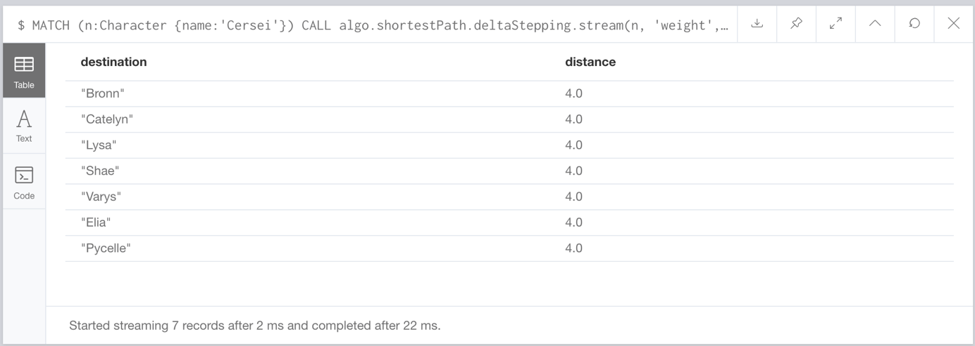

Figure 7. The characters with interaction distance 4 to Cersei Lannister

1. In order to find the parents of Jon Snow, the following query is used:

// finding the parents of Jon Snow

MATCH (char2:Character)-[r:RELATIONSHIP]->(char1:Character{name:'Jon'})

RETURN char1,r,char2;

The query returns the father connection of Jon Snow. There is no information on Jon’s mother in the dataset. The screenshot is available in Figure 8.



Figure 8. Parent Relations of Jon Snow.

1. For two characters to have a sibling relationship, it is assumed that one of their parents (mother or father) should be the same. The following query is used to create these relationships:

// Creating the sibling relationships.

MATCH ((kid1:Character)<-[:RELATIONSHIP]-(parent1:Character)) ,((kid2:Character)<-[:RELATIONSHIP]-(parent2:Character))

WHERE parent1.name=parent2.name

CREATE (kid1)-[r:RELATIONSHIP{tie:'Sibling'}]->( kid2)



1. To find the children of an incestuous relationship, I defined such a rule that if a character’s mother and father are siblings, then this character is a child of an incestuous relationship. For this purpose, I used the following query:

// children of incestuous relationships!

MATCH ((kid1_:Character)<-[:RELATIONSHIP{tie:'mother'}]-(parent1_:Character)) ,((kid1_:Character)<-[:RELATIONSHIP{tie:'father'}]-(parent2_:Character))

WHERE (parent1_:Character)<-[:RELATIONSHIP{tie:'Sibling'}]-(parent2_:Character)

RETURN kid1_,parent1_,parent2_

The resulting children of an incestuous relationship are listed in Figure 10.



Figure 10. The list of children born from an incestuous relationship.

1. <https://github.com/neo4j-contrib/neo4j-graph-algorithms>